Set 3 – Employee Performance Evaluation

- Line Chart – Monthly Performance/Sales Trend
Code:
library(ggplot2)

monthly_sales <- data.frame(
Month = c(
"January", "February", "March", "April",
"May"
),
Sales = c(15000, 18000, 22000, 20000, 23000)
)

ggplot(monthly_sales, aes(x = Month, y = Sales, group = 1)) +
geom_line() +
geom_point() +
labs(
title = "Monthly Sales Performance",
x = "Month",
y = "Sales"
) +
theme_minimal()

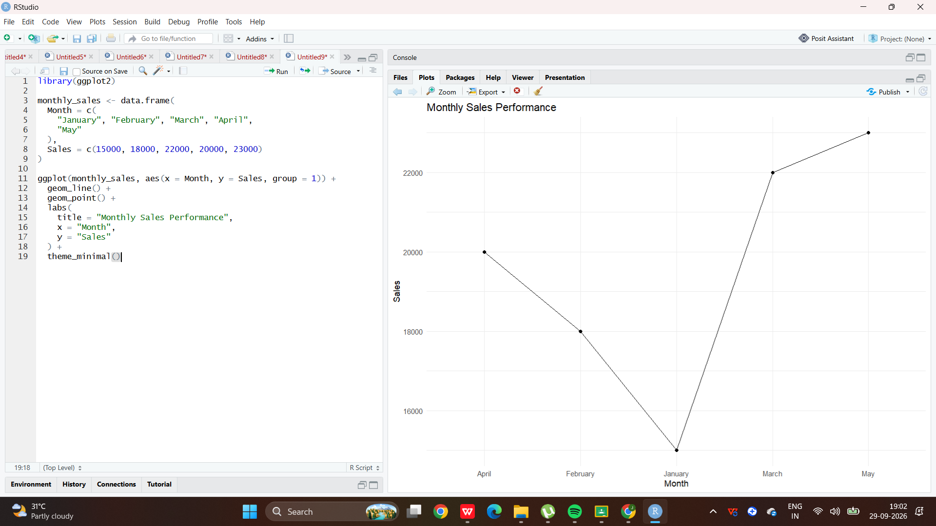

2.Bar Chart – Employees by Department
Code:
library(ggplot2)

employees <- data.frame(
Employee_ID = c(1, 2, 3, 4, 5),
Department = c(
"Sales", "HR", "Marketing", "Sales", "HR"
),
Years_of_Service = c(5, 3, 7, 4, 2),
Performance_Score = c(85, 92, 78, 90, 76)
)

ggplot(employees, aes(x = Department)) +
geom_bar() +
geom_text(
stat = "count",
aes(label = after_stat(count)),
vjust = -0.5
) +
labs(
title = "Employee Distribution by Department",
x = "Department",
y = "Number of Employees"
) +
theme_minimal()

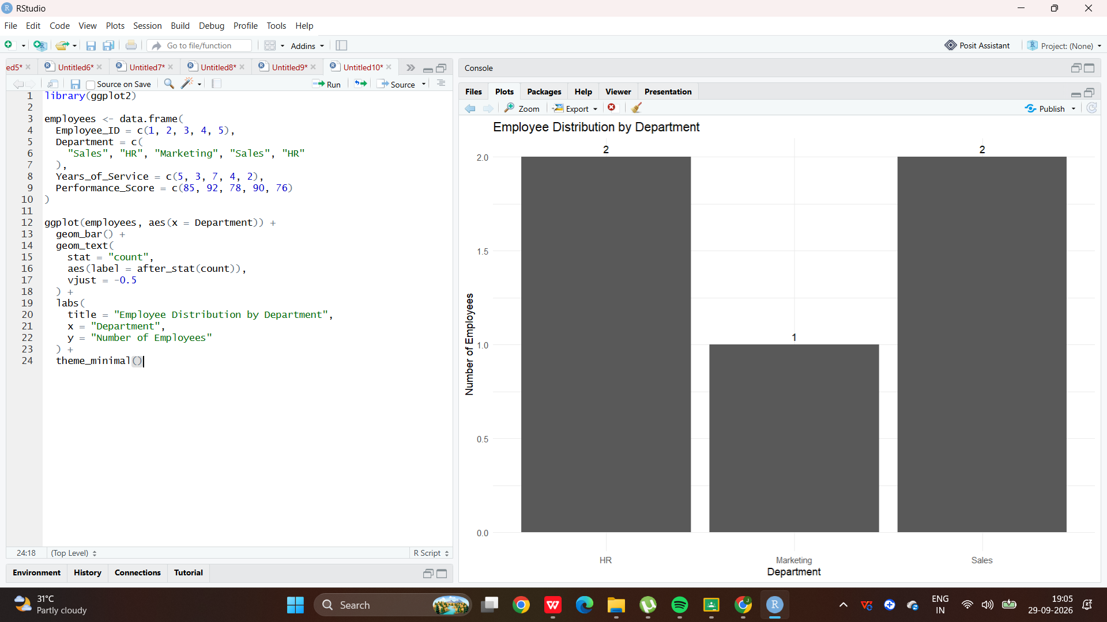

3.Scatter Plot – Years of Service vs Performance Score
Code:
library(ggplot2)

ggplot(
employees,
aes(x = Years_of_Service, y = Performance_Score)
) +
geom_point(size = 3) +
geom_smooth(method = "lm", se = FALSE) +
labs(
title = "Years of Service vs Performance Score",
x = "Years of Service",
y = "Performance Score"
) +
theme_minimal()

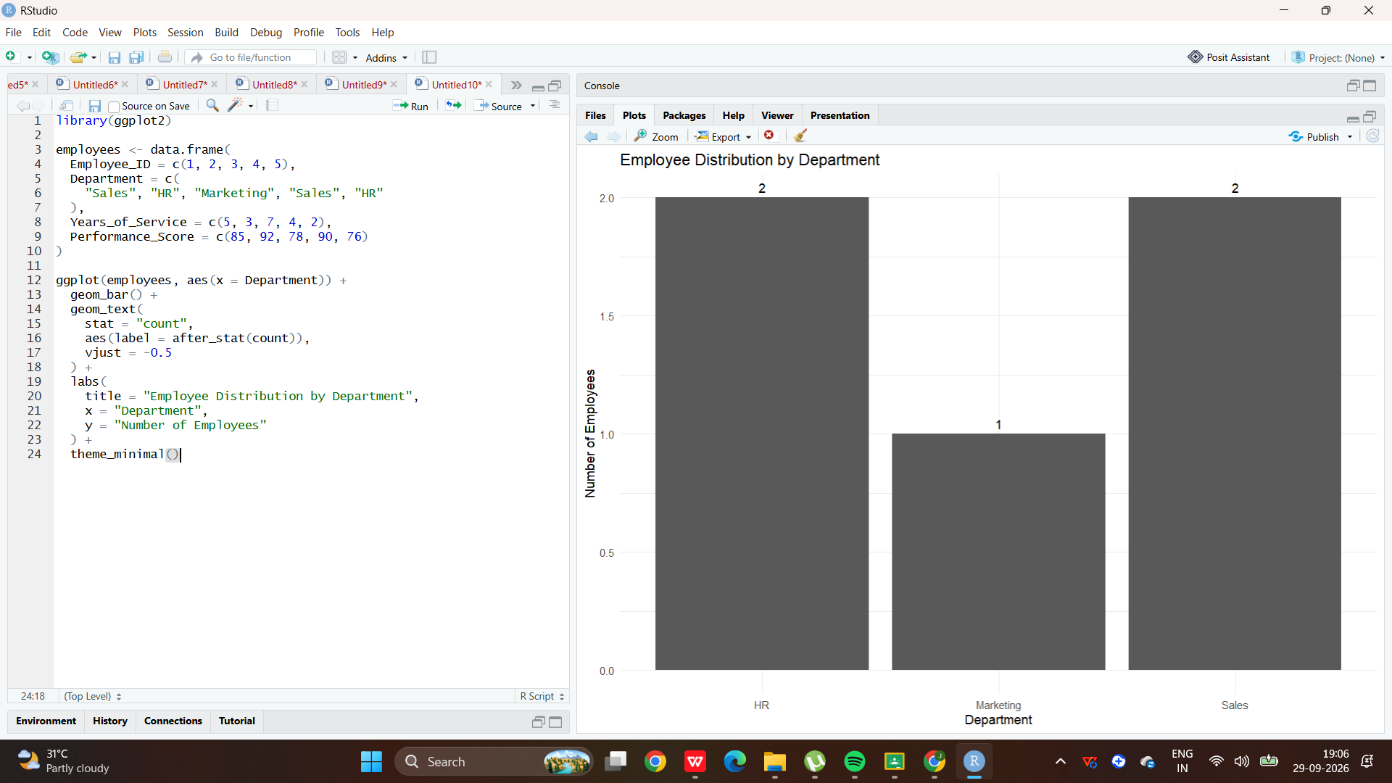

4.Interactive Dashboard
Code:
library(plotly)

# Line chart
line_chart <- ggplotly(
ggplot(monthly_sales, aes(x = Month, y = Sales, group = 1)) +
geom_line() +
geom_point() +
labs(
title = "Monthly Sales Performance",
x = "Month",
y = "Sales"
) +
theme_minimal()
)

line_chart

